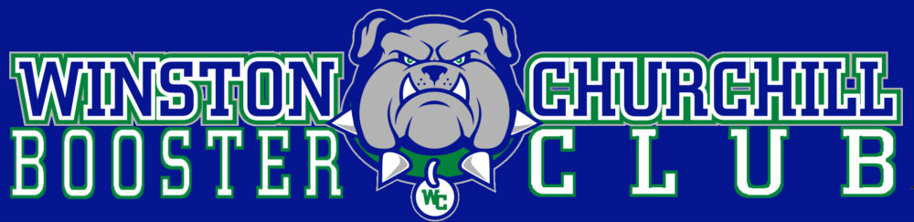
Please Sponsor Churchill Booster Club's Annual Fundraiser
Bulldog Bash at Tower Oaks Clubhouse on Friday, April 5, 2024

Platinum $500
Your company logo or family name will be prominently displayed at the event on the bar, screens throughout the venue, registration table, on the online invitation and event website as well as the official Booster Bash Banner displayed at the event and at Churchill HS for the 2023-2024 school year.

Gold $250
Your company logo or family name will be prominently displayed at the event on the bar, screens throughout the venue, and at the registration table as well as the official Booster Bash Banner displayed at the event and at Churchill HS for the 2023-2024 school year.

Silver $100
Your company logo or family name will appear on the official Booster Bash Banner displayed at the event and at Churchill HS for the 2023-2024 school year.

Two Easy Ways to Register as a Sponsor:

- You can register, pay, and receive instructions for uploading your logo online at https://www.churchillboosterclub.com/store-1/p/booster-bash-sponsorship

- Or you can mail this form and $100/$250/$500 check payable to "WCHS BOOSTER CLUB" to:
Rachael Datch
8000 Herb Farm Drive
Bethesda, MD. 20817

Company or family name as it should appear on the banner:
__________________________________________________

Email a high-resolution logo to wchsboosterbash@gmail.com
Company Contact Name:_________________________________
Phone:________________________ Email:__________________________________

Churchill Booster Club is a 501c(3) organization
www.churchillboosterclub.com Questions: wchsboosterbash@gmail.com

